What is a Spectrometer? UV, VIS, and IR Spectrometer Explained
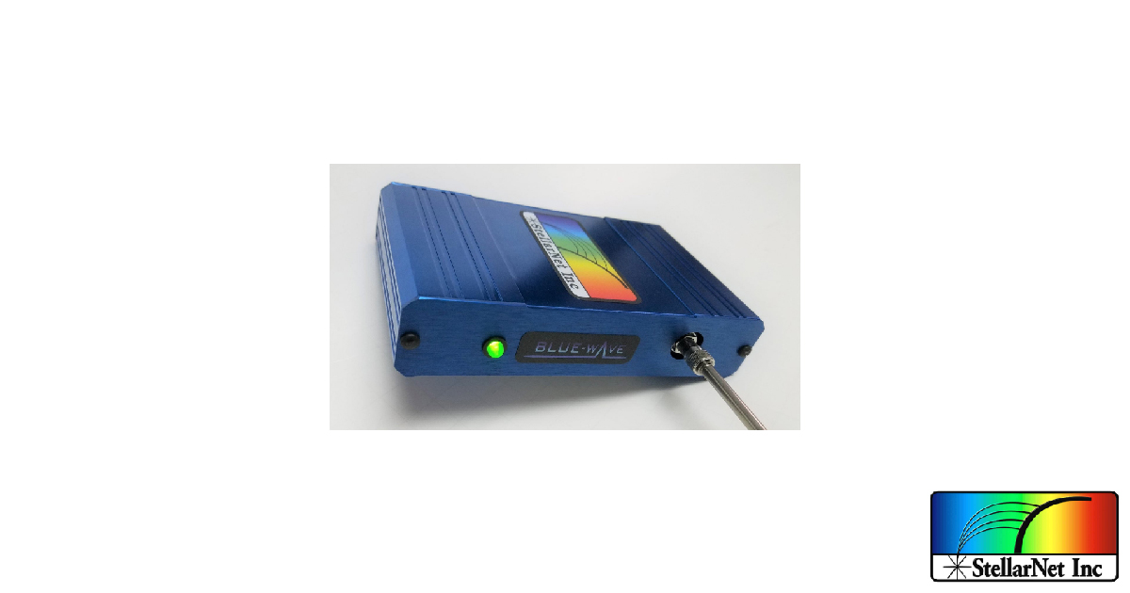

1. What is a Spectrometer?
Spectrometer is an umbrella term which describes an instrument that separates and measures spectral components of a physical characteristic. They are devices that measure a continuous variable in which the components of the spectrum are separated from their original mix.
There are several variations of spectrometers around and some of the most common ones present are Nuclear Magnetic Resonance (NMR) Spectrometer, Mass Spectrometer and Optical Spectrometer.

1.1 NMR Spectrometer
The NMR Spectrometer observes and measures the interaction of nuclei spins when the sample is placed in a strong, constant magnetic field. The NMR signal is produced when the nuclei interacts with the magnetic field at a frequency that resonates with the frequency of the nuclei.
The intramolecular magnetic field surrounding the atom in a molecule changes with the resonance frequency, therefore revealing the molecular structure of the sample.

1.2 Mass Spectrometer
A Mass Spectrometer measures the mass-to-charge ratio of ions and identifies the composition of elements present in a sample. This works by ionizing a sample, which causes some of the molecules to become charged and separate according to their mass-to-charge ratio.
These ions are then detected by a device that can detect charged particles.

1.3 Optical Spectrometer
An Optical Spectrometer measures the properties of light, usually near the optical region in the electromagnetic spectrum, i.e. ultraviolet, visible and infrared light.
The change in the absorption and emission of the light intensity with wavelength allows for materials to be identified.
In this article, we will be focusing on the Optical Spectrometer.

2. Working Principle of a Spectrometer
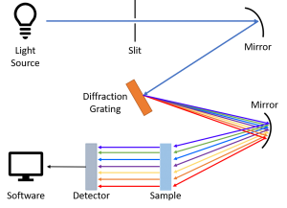
A spectrometer consists of three main components – entrance slit, grating and detector.

2.1 Entrance Slit
Light from the source enters the entrance slit and the size of the slit determines the amount of light that can be measured by the instrument. The slit size also affects the optical resolution of the spectrometer, where the smaller the slit size, the better the resolution.
The beam becomes divergent after passing through the slit and by reflecting the divergent beam on a collimating mirror, the beam becomes collimated. Collimated rays are then directed towards a diffraction grating. The grating acts as a dispersive element and splits the light into its constituent wavelengths.

2.2 Grating
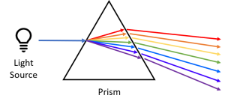
A monochromator uses a phenomenon of optical dispersion in a prism or diffraction from diffraction gratings to select a particular wavelength of light. In traditional spectrometers, prisms were used to disperse light.
However, with the invention of the diffraction grating, it became the most used monochromator in modern spectrometers as it has more advantages over the prism.
Both devices are capable of splitting light into several colours, but a diffraction grating can be made to spread the colours over a bigger angle than a prism. Prisms also have a higher dispersion only in the UV region while diffraction gratings have a high and constant dispersion across the UV, VIS and IR spectrum.
Once the light hits the diffraction grating, each wavelength is reflected at a different angle. Diffraction grating of different sizes are also used to determine different wavelength ranges.
The beam becomes divergent again after being reflected from the grating, thus it hits a second mirror to focus and direct it towards the detector.

2.3 Detector
The detector captures the light spectra and measures the intensity of light as a function of wavelength. These data are then digitized and plotted onto a software as a graph.

3. Parts of a Spectrometer
The section above talked about how a spectrometer works. In this section, the components of a spectrometer and the variety for each component will be covered.

3.1 Light Sources
Light sources commonly found in a spectrometer are made of Tungsten Halogen, Deuterium, Xenon Arcs, LED, Mercury Argon, Zinc or Lasers.

3.2 Entrance Slit
Slits come in a variety of sizes, from 5μm to 800μm with a 1mm to 2mm height. The size of the slit depends on the application and the most common slits used are in widths 10, 25, 50, 100 and 200μm.

3.3 Mirrors
The most common types of mirrors around are usually plane and spherical mirrors. Spherical mirrors can be broken down into two types – concave and convex spherical mirrors. However, in a spectrometer, concave spherical mirrors are usually used.

3.4 Diffraction Gratings
There are two types of diffraction gratings available in the market – Ruled Grating and Holographic Grating.
A ruled grating is produced by physically etching grooves onto a reflective surface using a diamond-form tool on a ruling machine while a holographic grating is produced by a process known as interference lithography, which constructs an interference pattern using two UV beams.
Ruled gratings can be blazed for specific wavelengths and usually have a higher efficiency than holographic gratings.
Holographic gratings tend to have a more uniform groove form and spacing, and generate less stray light as they are produced optically.

3.5 Holders
Samples are usually liquids, but gases and solids can also be tested. The samples are usually placed inside a transparent cell, called cuvette. Test tubes can also be used in place of cuvettes in some equipment.
The material used to produce the cuvette depends on the spectral range that the spectrometer covers. Fused silica or quartz glass are commonly used as they are transparent through UV to IR regions.

3.6 Detectors
There is a wide variety of detectors being used in different spectrometers and some commonly used detectors are the photomultiplier tube (PMT), photodiode, photodiode array, charge-coupled device (CCD), bolometer and multi-channel analyser (MCA).

3.7 Interface
Most spectrometer systems interface with the computer via USB, RS-232 or Ethernet. With technology advances, newer systems are able to transfer data wirelessly using Wi-Fi and Bluetooth.

3.8 Software
Many software can be implemented for usage with spectrometers for data acquisition. Most companies producing the instrument would also provide software that is compatible with the spectrometer they produce. For example, StellarNet’s spectrometers come with their software known as SpectraWiz.
On top of such ready-made software, there are others that allow you to code and create your own program, and customize it according to your needs, i.e. LabVIEW, Visual C, C#, VB, VBA for MS Excel and MATLAB.

4. Use of Spectrometer
There are several usage of a spectrometer.
One example, a UV spectrometer that utilizes a spectral range of 200 – 400nm, installed with an entrance slit of width 200μm, together with a holographic grating with groove size of 2400g/mm, and with a CCD detector of 2000 pixels, can detect impurities in organic molecules – such as benzene, that is a common impurity found in cyclohexane and its presence can be easily detected by its absorption with a peak at 255nm in the spectrum.

5. Types of Optical Spectrometers
Optical Spectrometers can be classified in two ways. The first way is by their wavelength while the second way is by their light interaction properties.

5.1 Wavelength
- Ultraviolet (UV)
UV spectroscopy uses light in the UV range of wavelength between 200 – 400nm to measure how much light a sample absorbs or reflects, and to determine the concentrations of elements in the sample.
The electrons in the sample are excited from ground state to a higher energy state as the molecules absorb the energy given off by the UV light. The amount of energy the electrons have is proportional to the length of the wavelength it can absorb.
The identification of the sample is done by comparing the spectrum produced when the sample absorbs the UV light with spectrums of known compounds.
A UV Spectrometer typically uses deuterium arc, xenon arc or tungsten halogen lamps. The type of grating used is usually holographic grating and the detector employed is usually a PMT, photodiode, photodiode array or CCD. The detectors usually come with a pixel size of 14μm by 200μm.
A UV Spectrometer is commonly used in industries such as Material Science, Quality Control, Petrochemistry, Food & Agriculture, Life Science, Optical Components, etc.
It is also usually used in applications such as detection of impurities, and presence or absence of any functional group in a compound, identification of compounds, structural elucidation of organic compounds, etc.
- Visible (VIS)
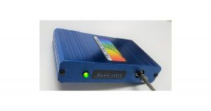
Learn More
A VIS spectrometer works in the same way as the UV spectrometer, except that this utilizes light in the visible region of the electromagnetic spectrum, i.e. wavelength of 400nm to 700nm, to identify compounds that do not interact with UV light.
This instrument can also determine the concentration of substances in a sample by measuring its transmittance or absorbance intensity.
Tungsten halogen, xenon lamps and LEDs are usually used as light sources in a VIS spectrometer.
It utilizes the same type of diffraction grating and detector as a UV spectrometer. The VIS spectrometer is also mainly used in the same industries and applications as the UV spectrometer.
- Infrared (IR)
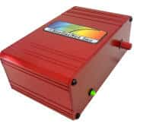
Learn More
IR spectrometer makes use of the vibrational transitions of an organic molecule with IR light to identify materials in the IR spectra.
IR light can be divided into three portions between 700nm to 1mm – near, mid and far infrared, which is in relation to the visible spectrum.
Photons from mid-IR onwards is only able to induce vibrational excitations in covalently bonded atoms and are not able to excite electrons as the energies are not large enough.
The sample absorbs the IR radiation and corresponds in energy to these vibrations. This allows the absorption spectra of compounds to be recorded and the spectra is unique to each compound.
Fourier-transform IR (FTIR) Spectrometer, which collects data over a wide range, utilizes Fourier transform to convert raw data into a spectrum.
Near, mid and far-IR uses tungsten-halogen lamp, globar and mercury Lamp, respectively. The type of grating installed is usually ruled grating. NIR spectrometers typically use InGaAs photodiodes with a pixel size of 25μm by 500μm while MIR spectrometers use pyroelectric detectors with a pixel size of 48.5μm by 48.5μm and FIR spectrometers use a-Si or VOx bolometers of 75μm by 75μm pixel size.
This can usually be found in industries such as Pharmaceuticals, Environmental Safety, Food and Materials. Applications that utilizes IR spectrometer includes protein characterization, space exploration, identification of compounds, nanoscale semiconductor analysis, etc.

5.2 Interactions
- Absorption
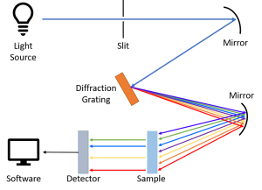
As its name suggests, absorption spectroscopy measures the absorption of radiation, as a function of wavelength or frequency, of a sample with the source.
The sample absorbs energy from the source and the intensity of absorption varies with frequency, this variation then produces the absorption spectrum. This method of spectroscopy is done across the electromagnetic spectrum.
Absorption spectroscopy is used to determine compounds present in a sample and to measure the concentration of it. UV, VIS and IR spectroscopy mentioned above are examples of absorption spectroscopy.
The most common light source used in absorption spectrometry is a hollow cathode lamp and a PMT is used as the detector. This is often used in remote sensing, astronomy and atomic and molecular physics.

- Reflectance
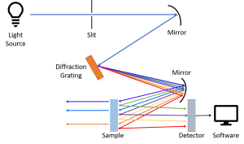
Reflectance spectroscopy measures the amount of light that has been reflected or scattered from a sample.
Photons from the source that are reflected from the sample or refracted through the sample are said to be scattered.
These scattered photons are then detected and recorded. This results in a reflectance versus wavelength plot.
Reflectance spectroscopy systems usually use lasers, superluminescent diodes, LEDs, or halogen lamps as its light source and CCDs, photodiodes or MCA as its detector.
The reflectance spectrometer is used in the medical industry to provide information on tissues concentration and can also be used in industries like environmental science and geology.
- Transmittance
Transmission spectroscopy refers to the measurement of the amount of light that passes through a sample unchanged.
It is very much interrelated to absorption spectroscopy, hence they share a similar setup.
A transmission spectrum will have its highest peaks at wavelengths where absorption is weakest as more light passes through the sample.
Depending on spectral range, different light sources are used. LEDs, Tungsten halogen, or deuterium lamps are frequently used. Typical detectors chosen are photodiodes and CCDs. This is often used in pharmaceutical analysis.
- Fluorescence
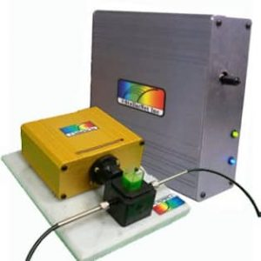
As mentioned in UV spectroscopy, electrons in a sample become excited when it absorbs light and moves from ground state to a higher electronic state which consists of various vibrational states.
The excited electrons can transit to its ground state by emitting a photon and this process is known as fluorescence.
As the electrons may drop into any of the various vibrational levels in the ground state, the emitted photons will contain different amount of energies, and thus varying intensities and wavelengths.
Fluorescence spectroscopy is therefore defined as the measurement of the amount of fluorescence from a sample. It usually uses light in the UV or VIS range for excitation of electrons.
Fluorescence is measured by fluorescence spectrometers and it measures various characteristics of fluorescence, such as intensity and wavelength distribution of the emission. The emission spectrum then reveals which wavelengths the samples emit.
Instruments that measure fluorescence are known as fluorometers. Fluorometers typically use lasers, LED, xenon arc or mercury vapour lamps as its light source. Photodiodes or PMTs are usually selected as detectors in fluorescence spectroscopy.
This spectroscopy method can be commonly found in medical, biochemical and environmental monitoring industries. Applications include cancer diagnostics in human tissues, to detect impurities or identify and measure concentrations of substances, and to detect various bacteria, viruses and parasites that are causing infections.
- Scattering
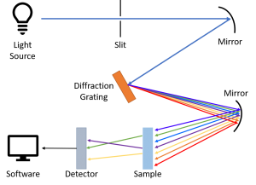
When light passes through matter, most of it continues in its original direction, however a small portion is scattered in other directions.
This technique is based on the theory of Raman scattering. Scattering effect is the inelastic scattering of photons by matter, which means that there is a change in direction of light and, energy is lost by the photons after interacting with the sample.
Usually, the molecules will gain vibrational energy from the incident photons.
Most of the light that gets scattered off is unchanged in energy and this is Rayleigh scattering. Raman scattering is made up of an extremely minute fraction of scattered photons (approximately 1 in 10 million).
By analysing the vibrational change in the sample, properties such as chemical composition, crystallinity, molecular interactions can be determined. As mentioned above, Raman scattering is very weak, therefore a highly sensitive spectrometer is needed to examine the light.
This instrument is commonly used in industries such as chemistry, physics, pharmaceutical, arts and medical. It helps to identify molecules and examine chemical bonding, characterise and study the structures of materials, discover counterfeit drugs in packages, studying biominerals, etc.

6. Raman Spectrometer
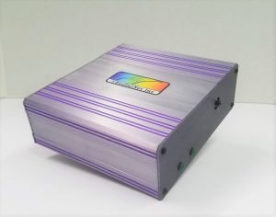
Raman spectroscopy is based on the interaction of light (typically a laser) with a material’s chemical bonds.
Light is scattered directly off the sample and passed through a filter to remove the particles from Rayleigh scattering.
The remaining light from Raman scattering is then directed to a diffraction grating before heading towards the detector.
It eventually produces a Raman spectrum where each peak and intensity can provide some information on the sample.
Raman spectrometer uses only continuous-wave laser as its light source.
Lasers in the spectral range from red to NIR are usually used, however, the use of visible lasers in blue and green is increasing in recent years.
It also employs holographic grating as its monochromator and CCDs as its detector.

7. Spectrometer Vs. Spectrophotometer
People often confuse Spectrometer with Spectrophotometer. A spectrophotometer is an instrument that measures the transmission and absorption properties of light as a function of the wavelength of a material.
It typically deals with light in the range from near-ultraviolet to visible light to near-infrared. The spectrophotometer itself contains a spectrometer as well as a light source to better illuminate the sample.
The working principle is similar to the spectrometer, where a monochromator is used to select a wavelength of light to reach the sample. Depending on the sample’s opacity, the light is either reflected or transmitted. The detector then records the intensity of the reflected or transmitted light.
This is repeated with the monochromator at different wavelengths for the detector to measure the change in light intensity. The final output would be an absorption spectrum as a function of wavelength.

8. Where to Buy a Reliable Spectrometer?
Now that you know what is a spectrometer and its applications, you should know where to buy a reliable one. You can buy reliable spectrometers from Wavelength Opto-Electronic.
We are the distributor of StellarNet spectrometers, offering optical spectrometers for measurements in UV, VIS and NIR, from wavelengths of 190 – 2300nm. StellarNet spectrometers are designed to be portable, compact with no moving parts.

